PRATICAL-7
AIM: (i). Implementation of Python Libraries for ML application such as Pandas and Matplotlib.
- SOURCE CODE :
import pandas as pd import numpy as np
import matplotlib.pyplot as plt

# (a) Create a Series using pandas and display it
data = [10, 20, 30, 40, 50]
series = pd.Series(data)
print(series)

OUTPUT :-
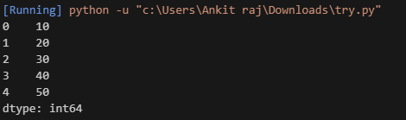

# (b) Access the index and values of the our Series
data = [10, 20, 30, 40, 50]
series = pd.Series(data)
print("Index:", series.index)
print("Values:", series.values)

OUTPUT :-

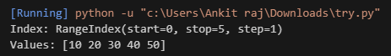

# (c) Compare an array using NumPy with a Series using pandas
array = np.array([10, 20, 30, 40, 50])
series = pd.Series([10, 20, 30, 40, 50])

print("NumPy Array:", array)
print("\nPandas Series:\n", series)

OUTPUT :-
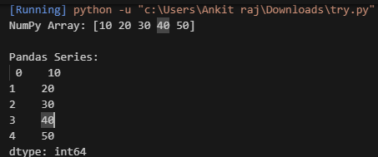

# (d) Define Series objects with individual indices
data = [100, 200, 300, 400, 500]
index_labels = ['a', 'b', 'c', 'd', 'e'] # Custom indices
series = pd.Series(data, index=index_labels)
print(series)

OUTPUT :-
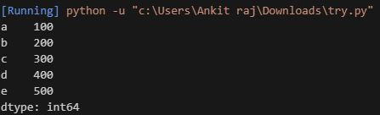
# (e) Access single value of a Series
data = [100, 200, 300, 400, 500]
index_labels = ['a', 'b', 'c', 'd', 'e']
series = pd.Series(data, index=index_labels)
print("Value at index 'c':", series.loc['c'])
print("Value at position 2:", series.iloc[2])

OUTPUT :-
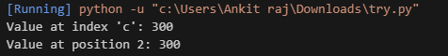
# (f) Load datasets in a DataFrame variable using pandas
df = pd.read_excel(r"C:\Users\saifa\Downloads\Saif Data.xlsx") print("Iris Dataset (First 5 rows):")
print(df.head()) print("Has Been Printed")

OUTPUT :-
Iris Dataset (First 5 rows):
Sr. No. Admission No Name
0 1 11232503 AJIT SAH
- 2 11232506 AASHISH KUMAR MEHTA
- 3 11232507 AASHUTOSH KUMAR SAH
- 4 11232508 ABHAY SINGH
- 5 11232509 ABHINAV GARG
Has Been Printed

# (g) Usage of different methods in Matplotlib

x = np.linspace(0, 10, 100) y = np.sin(x)
plt.plot(x, y, label="Sine Wave", color='b', linestyle='--') plt.title("Sine Wave")
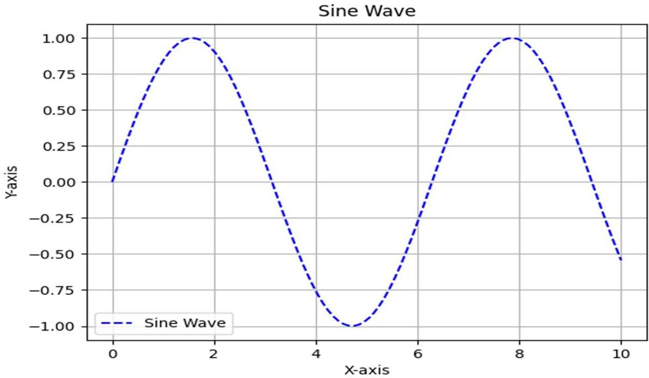
plt.xlabel("X-axis") plt.ylabel("Y-axis") plt.grid(True) plt.legend() plt.show()

OUTPUT :-

(ii) a) Creation and Loading different types of datasets in Python using the required libraries. import pandas as pd
import numpy as np from scipy import stats
from sklearn.preprocessing import MinMaxScaler import os

# Step 1: Create and Save CSV File csv_filename = "sample_dataset.csv"

# Creating sample data data = {
'Name': ['Alice', 'Bob', 'Charlie', 'David', 'Eve'], 'Age': [25, 30, 35, 40, 28],
'Salary': [50000, 60000, 70000, 80000, 55000]
}

# Creating DataFrame df = pd.DataFrame(data)

# Save dataset as CSV if not exists if not os.path.exists(csv_filename):
df.to_csv(csv_filename, index=False)
print(f"CSV file '{csv_filename}' has been created successfully.") else:
print(f"CSV file '{csv_filename}' already exists.")

# Step 2: Load CSV Dataset
df_csv = pd.read_csv(csv_filename) print("\nLoaded CSV Dataset:\n", df_csv)

# Step 3: Compute Mean, Median, Mode, Variance, Standard Deviation mean_value = df_csv['Salary'].mean()
median_value = df_csv['Salary'].median()

# Fix mode issue for newer SciPy versions
mode_result = stats.mode(df_csv['Salary'], keepdims=True)
mode_value = mode_result.mode[0] if mode_result.mode.size > 0 else None

variance_value = df_csv['Salary'].var() # Sample variance (pandas default) std_dev_value = df_csv['Salary'].std() # Sample standard deviation (pandas default)

print(f"\nMean Salary: {mean_value}") print(f"Median Salary: {median_value}") print(f"Mode Salary: {mode_value}") print(f"Variance of Salary: {variance_value}")
print(f"Standard Deviation of Salary: {std_dev_value}")

# Step 4: Data Preprocessing Techniques

# 1. Reshaping the Data (For demonstration, creating a NumPy array) data_array = np.array([[1, 2, 3], [4, 5, 6]])
reshaped_data = data_array.reshape(3, 2) print("\nReshaped Data:\n", reshaped_data)

# 2. Filtering the Data (Filtering Age > 30) filtered_df = df_csv[df_csv['Age'] > 30] print("\nFiltered Data (Age > 30):\n", filtered_df)

# 3. Merging Data
data2 = {'Name': ['Alice', 'Bob', 'Charlie', 'David', 'Eve'],
'Department': ['HR', 'IT', 'Finance', 'Marketing', 'Sales']} df2 = pd.DataFrame(data2)
merged_df = pd.merge(df_csv, df2, on='Name') print("\nMerged Dataset:\n", merged_df)

# 4. Handling Missing Values (Introduce and Fix Missing Values) df_csv.loc[2, 'Salary'] = np.nan # Introduce NaN in Salary column

df_csv['Salary'] = df_csv['Salary'].fillna(df_csv['Salary'].mean()) # Fix missing values print("\nDataset after Handling Missing Values:\n", df_csv)

# 5. Feature Normalization (Min-Max Normalization) scaler = MinMaxScaler()
df_csv['Salary_Normalized'] = scaler.fit_transform(df_csv[['Salary']]) print("\nMin-Max Normalized Salary:\n", df_csv):

OUTPUT :
CSV file 'sample_dataset.csv' already exists.

Loaded CSV Dataset: Name Age Salary
0 Alice 25 50000

1 Bob | 30 | 60000
2 Charlie | 35 | 70000
3 David | 40 | 80000
4 Eve | 28 | 55000

Loaded Iris Dataset from sklearn:
sepal length (cm) sepal width (cm) petal length (cm) petal width (cm)

0 | 5.1 | 3.5 | 1.4 | 0.2
1 | 4.9 | 3.0 | 1.4 | 0.2
2 | 4.7 | 3.2 | 1.3 | 0.2
3 | 4.6 | 3.1 | 1.5 | 0.2
4 | 5.0 | 3.6 | 1.4 | 0.2

Mean Salary: 63000.0
Median Salary: 60000.0
Mode Salary: 50000
Variance of Salary: 145000000.0
Standard Deviation of Salary: 12041.594578792296

Reshaped Data:

[[1 2]
[3 4]
[5 6]]

Filtered Data (Age > 30): Name Age Salary
2 Charlie 35 70000
3 David 40 80000

Merged Dataset:
Name Age Salary Department
0 Alice 25 50000 HR

1 Bob | 30 | 60000 | IT
2 Charlie | 35 | 70000 | Finance
3 David | 40 | 80000 | Marketing
4 Eve | 28 | 55000 | Sales

Dataset after Handling Missing Values: Name Age Salary
0 Alice | 25 50000.0
1 Bob | 30 60000.0
2 Charlie | 35 61250.0
3 David | 40 80000.0
4 Eve | 28 55000.0

Min-Max Normalized Salary:

Name | Age Salary | Salary_Normalized
0 Alice | 25 50000.0 | 0.000000
1 Bob | 30 60000.0 | 0.333333
2 Charlie | 35 61250.0 | 0.375000
3 David | 40 80000.0 | 1.000000
4 Eve | 28 55000.0 | 0.166667

